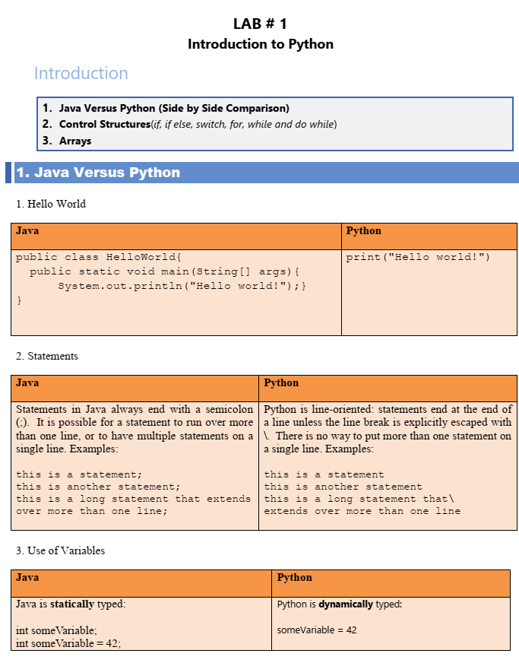

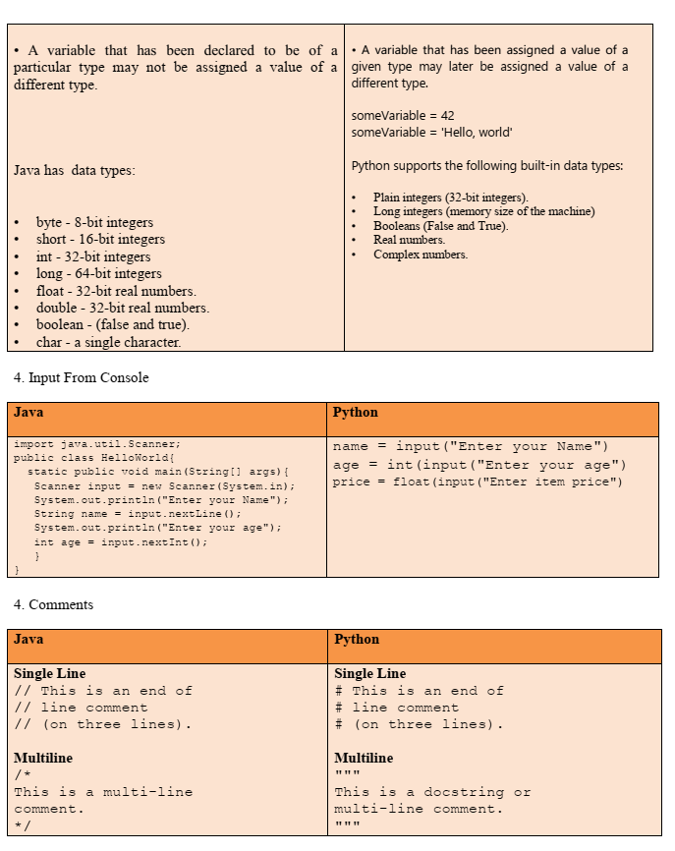

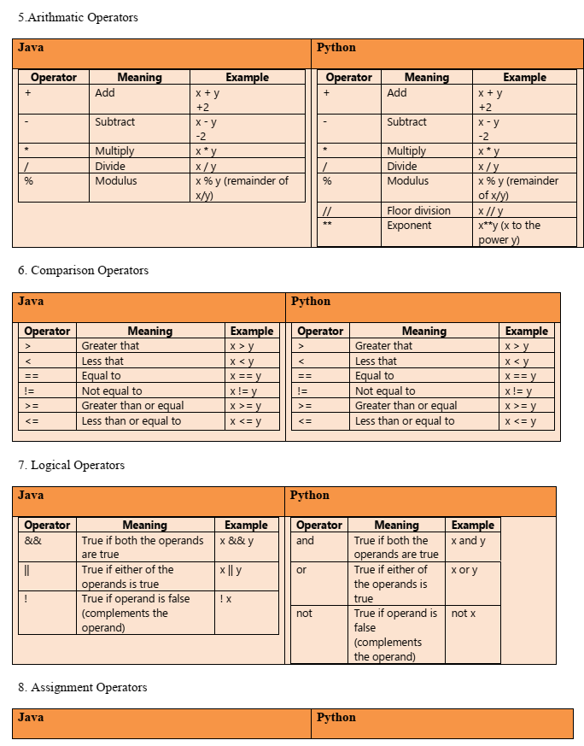

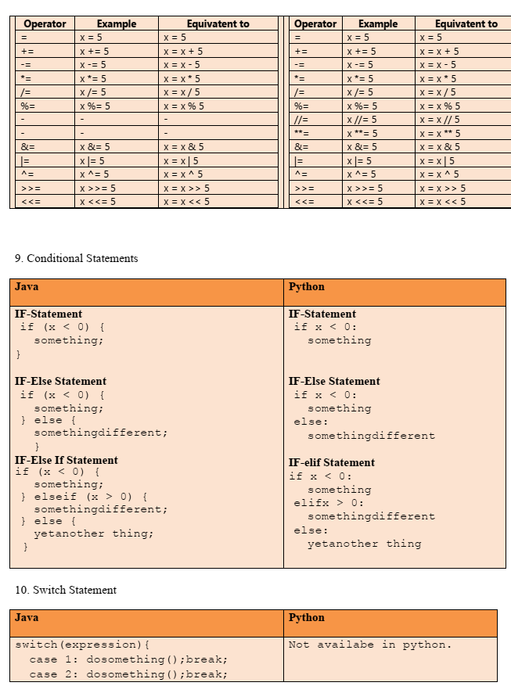

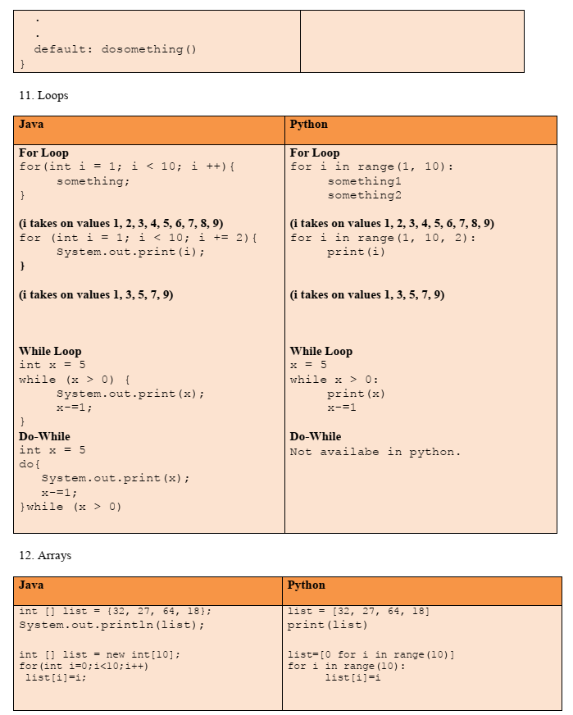

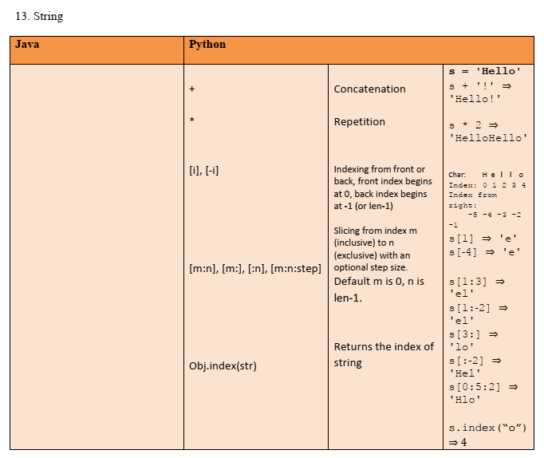

**Lab Tasks:**

1. **Add two values x = 7.8 and y = 9 and print answer in integer**

**Code**

x = 7.8

y = 9

result = x + y

print(int(result))

**Output**

16

=== Code Execution Successful ===

1. **Make a calculator**

**Code**

def calculator():

    print("This is a Calculator!")

    print("Select operation:")

    print("1. Add")

    print("2. Subtract")

    print("3. Multiply")

    print("4. Divide")

    operation = input("Enter choice (1/2/3/4): ")

    if operation in ['1', '2', '3', '4']:

        num1 = float(input("Enter first number: "))

        num2 = float(input("Enter second number: "))

        if operation == '1':

            result = int(num1 + num2)

            print(f"{int(num1)} + {int(num2)} = {result}")

        elif operation == '2':

            result = int(num1 - num2)

            print(f"{int(num1)} - {int(num2)} = {result}")

        elif operation == '3':

            result = int(num1 * num2)

            print(f"{int(num1)} * {int(num2)} = {result}")

        elif operation == '4':

            if num2 != 0:

                result = int(num1 / num2)

                print(f"{int(num1)} / {int(num2)} = {result}")

            else:

                print("Error! Division by zero.")

    else:

        print("Invalid input! Please enter a valid operation.")

calculator()

**Output**

This is a Calculator!

Select operation:

1. Add

2. Subtract

3. Multiply

4. Divide

Enter choice (1/2/3/4): 3

Enter first number: 5

Enter second number: 6

5 * 6 = 30

=== Code Execution Successful ===

1. **Write a Python program that accepts the radius of a circle from the user and compute the area**

**Code**

import math

def calculate_circle_area():

    radius = float(input("Enter the radius of the circle: "))

    area = math.pi * radius * radius

    print(f"The area of the circle is: {area:.2f}")

calculate_circle_area()

**Output**

Enter the radius of the circle: 20

The area of the circle is: 1256.64

=== Code Execution Successful ===

1. **Write a Python program to make a mark sheet**

**Code**

def create_marksheet():

    print("Enter the marks for the following subjects:")

    subjects = ["Math", "Physics", "Chemistry", "Biology", "English"]

    total_marks = 0

    for subject in subjects:

        marks = float(input(f"{subject}: "))

        total_marks += marks

    average_marks = total_marks / len(subjects)

    print("\nMark Sheet")

    print("-" * 20)

    for subject in subjects:

        print(f"{subject}: {marks}")

    print("-" * 20)

    print(f"Total Marks: {total_marks}")

    print(f"Average Marks: {average_marks:.2f}")

create_marksheet()

**Output**

Enter the marks for the following subjects:

Math: 60

Physics: 72

Chemistry: 69

Biology: 70

English: 80

Mark Sheet

--------------------

Math: 80.0

Physics: 80.0

Chemistry: 80.0

Biology: 80.0

English: 80.0

--------------------

Total Marks: 351.0

Average Marks: 70.20

=== Code Execution Successful ===